CrowdSync: issues of using Crowds in Video Synchronization Process

Abstract
This paper presents the use of crowdsourcing techniques and concepts in video synchronization (CrowdSync). It presents a categorization of activities related to synchronizing correlated videos, the basic foundations for understanding the proposal, its challenges and approaches for synchronization using the crowdsourcing production model and possible forms for users to interact with video. This paper does not presents a single approach for video synchronization using crowdsourcing, instead, it raises possibilities and challenges for this kind of approach.
1. Introduction
During a random event (a planned or unplanned happening that draws people's attention), regardless of its size, it is most unlikely not to see one or dozens of people recording what is happening, either from professional devices used by TV channels, photographic equipment or cameras from mobile devices. Figure 1 shows dozens of people recording the passing of Pope Francis through the streets of Manila, during his visit to the Philippines. Being captured from non-related people and from different devices, videos are then presented isolated. However, if presented together, viewers could obtain more details of the event, details which may be shown in a particular video but missing in others, and even a retelling of the story from recorded video: for instance, during the passing of the Pope, if all videos and photos were gathered together, it would be possible to tell how was the Pope's passing by using only content recorded by present people, the crowd.
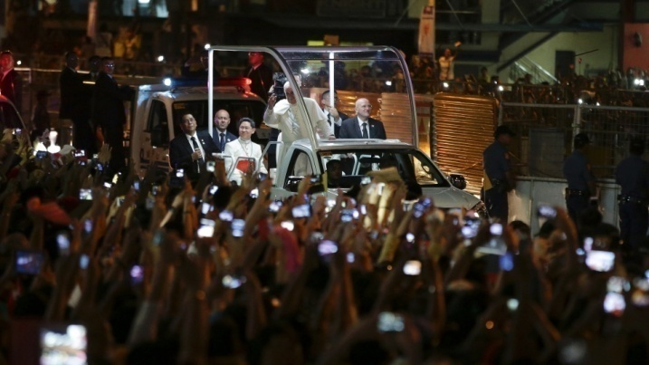
Figure 1. Crowd capturing the passing of Pope Francis.
Source: http://goo.gl/GJquxd
To make this type of experience possible, video must be presented synchronously, so users can switch between them without losing the linearity of the event, or show all videos simultaneously. For this, several techniques might be used: like using devices that, while capturing, they create synchronization points between videos (synchronized cameras); software that takes a set of videos as an input and then outputs synchronized videos (automatic solutions); and editing software used by professionals to define links between videos. However, many of these approaches have many dependencies, like static cameras, exclusive focus on captured objects, time and the need for professionals involved during the process. In videos captured from different events, however, they are not controlled, each user records whatever he wants, whenever and during the time he wants; users only think about capturing the moment.
The amount of video demands synchronization processes for presenting them consistently. This approach must be simple, cheap and computationally viable. This paper presents a proposal that meets these requirements and it is based on using the human factor for generating video synchronization of an event, that is, the application of crowdsourcing aspects. Using the crowd to synchronize videos has the following advantages: the use of human perception to identify common points between videos, without necessarily knowing what to look (ability of humans for finding patterns) ; the definition of small tasks that are handled by several users in order to find synchronization points, instead of being forced to single-handed watch all videos; independence of specific video formats required by some techniques (an encoding that allows the crowd to view and understand videos is enough); due to human perception, aspects that influence directly in automatic techniques can be overcome. However, disadvantages of using the crowd must be highlighted: dependence of participation from those who capture videos and from users that collaborate during the synchronization process; synchronization is only possible after a certain contribution time from collaborators.
Using the crowd for synchronization brings the following characteristics to the process:
- Client-side processing: synchronization will take place at the client-side. Complex algorithms cannot depend on local requirements, which are unknown, in this case, ranging from a top computer to a tablet or smartphone;
- Uncertainty: there are no prior knowledge of which videos will be synchronized, neither their characteristics and duration, making difficult to determine an generalized automatic technique for video synchronization;
Besides analyzing videos to synchronize them, the crowd can play different roles within the synchronization process: video capturing; clustering; validation and edition.
2. Crowdsourcing
Defining crowdsourcing is not an easy task. Different papers present several definitions, oftentimes classifying the same system as being crowdsourcing in a paper and not in another. For this paper we adopt the following definition of crowdsourcing, which is the result of a systematic review from the several definitions found in literature [2]:
“Crowdsourcing is a type of participative online activity in which an individual, an institution, a non-profit organization, or company proposes to a group of individuals of varying knowledge, heterogeneity, and number, via a flexible open call, the voluntary undertaking of a task. The undertaking of the task, of variable complexity and modularity, and in which the crowd should participate bringing their work, money, knowledge and/or experience, always entails mutual benefit. The user will receive the satisfaction of a given type of need, be it economic, social recognition, self-esteem, or the development of individual skills, while the crowdsourcer will obtain and utilize to their advantage what the user has brought to the venture, whose form will depend on the type of activity undertaken.”
Besides possible definitions, several different classifications can be found for crowdsourcing systems. Similarly to the definition, to describe features related to crowdsourcing concepts in the future, this paper will adopt definitions found in secondary reviews, which group several concepts present in different papers and build a consistent classification to use in future work. The nine dimensions for crowdsourcing systems presented in [4] are an example of classification. These are: Nature of collaboration (explicitly or implicitly); Type of target problem (any problem defined by system owners); how to recruit and retain users; what can users do; how to combine their inputs; how to evaluate them; degree of manual effort; role of human users; standalone versus piggyback architectures.
[5] describes what types of problems can be solved through crowdsourcing: Knowledge Discovery and Management; Distributed Human Intelligence Tasking Organization; Broadcast Search; Peer-Vetted Creative Production;
Besides classification, the paper presents a decision tree (Figure 2) which guides researchers on how to identify the problem that is being addressed. Applying this tree to our problem, we came to the conclusion that the C-SYNC problem can be classified as a “Distributed Human Intelligent Tasking” problem, where an organization sends task related to information analysis. For this, in the first fork we choose the A path, since we are dealing with an information management problem, where the crowd will use information contained in videos to generate synchronization points. As for the second fork, the chosen path is B, since information is already available and it is unnecessary to locate it.
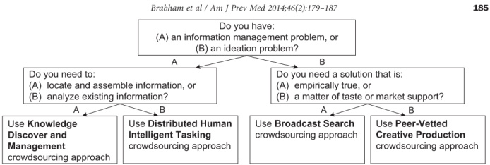
Figure 2. Decision tree
3. Problem Dimensions
The goal of video synchronization is to align a set of videos α in a common temporal line. For this, consider α1 and α2 having the same frame rate. They are considered to be synchronized when, in a given time T_{K} at the k-nth frame of α1 and T_{M} at the m-nth frame of α2, they both correspond to the same instant in time, which is an instance of continuous space-time.
Next, different attributes that influence in this synchronization process are presented.
3.1. Degree of similarity
Visual similarity influences in the synchronization method to be applied in a set of captured videos, within the same spatiotemporal context. For example, videos that are too much alike may confuse participants from the crowd looking to synchronize them, but can also favor automatic techniques that look for small differences between frames to identify videos. Thus, four similarity categories were established for content from videos captured at the same time and related to the same event, or as defined in [24], UGVs – Unorganized and Unsynchronized User Generated Videos.
Figure 3 shows these categories. Each line represents a video to be synchronized (V) and the objects (O) are elements on the videos that might be used as points to synchronize the videos.
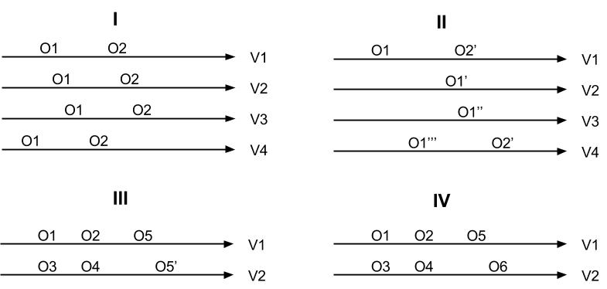
Figure 3. similarity categories from scene objects
I. Almost identical: these videos present very similar scene objects during their duration, merely displaced inside the temporal line from each video. An example are side-by-side cameras that are filming the same event, like cameras in a football stadium belonging to different TV channels but filming the same match, at a similar angle view. Similar (visually) objects appear at scene during all of the capturing time of videos;
II. Visually different: captured scene objects in videos are practically the same during all of their duration; however, they are captured from different view angles. In the same previous example, a TV channel offers several views of a same play, captured from the multiple available cameras.
III. Similarity by intervals: there are correlated intervals in the videos, with the same scene objects, but most of contents are visually different.
IV. Contextual: videos present the capture of a common event, however, similar objects are rare or nonexistent, requiring the use of information that is not obtained from video frame processing in order to achieve synchronization. Audio tracks or content marks can be used to automatically solve this problem [23][24].
3.2. Duration
A video's duration influences directly in its synchronization with other videos. The longer a video most likely it is to be related to other videos in the same group. The longest video, having the higher chance of being related to other videos, is a natural candidate to serve as a basis to synchronization methods that may be used. On the other side, the longer the video, the more difficult it is to find relations between them, since there is more content to be compared in order to find synchronization points. In an automatic tool, the longer the video is, the greater its computational requirements. When using the crowd, a larger number of analyses from the crowd will be required to find synchronization points.
3.3. Continuity
The fact of a video not being continuous is directly related to a given synchronization. A discontinuity (segmentation) in a video content capture may happen because of:
- A sudden or gradual transition in a shot, generally caused by a change of camera or scene. In this case, the user does not notices a break of content continuity, despite reducing the consistency of visual content from sequential video frames;
- A scene transition, from the change of context of the content or an edition made on the captured content. In this case, there is a noticeable break of linearity of content and this implies in a sudden interruption of visual consistency of consecutive video frames.
When there is a change of scene, without losing the linearity between scenes, and a synchronization point is identified, it will be possible to synchronize an entire video with other videos. However, change of scenes will make the synchronization process more difficult: common points can be lost when there is a change of scene, impairing automatic and crowd based methods. Yet, at the same time, the change of scenes can indicate a particular happening in the video (a goal, an explosion, etc...), since there is a change of focus. This can be used as a reference for looking synchronization points.
When there is a temporal interruption, video linearity is lost and, even when two videos are synchronized it is not guaranteed that they will remain synchronized at both their ends, since an interruption will displace the temporal line of one of them. A reference point before and after a temporal breakdown will be needed to synchronize other videos correctly.
3.4. Presentation Time
The way generated videos are presented leads to different problem domains. Presentation is understood as the way videos are generated, streamed and displayed to viewers, either in real time (live) or when captured, uploaded to a repository and only later accessed by viewers (on demand).
In a live presentation, the past and future of videos are not of great importance, since the main goal is to present them in real time. In case a video is not synchronized at the time of presentation, such synchronization has no value to the user, since he will not access this content later. Then, it is of extreme importance that the synchronization method operates at the time that a video is being displayed.
In an on demand presentation, this is not a requirement and synchronization can take place after videos have been stored. However, in this case, relation between videos is also unknown, requiring an analysis of the entire video duration as the search space.
3.5. Group Presentation
The way integrated content from multiple videos is presented in the screen, to end users, can influence in the level of required synchronization. In a presentation with multiple videos, simultaneously sharing the same presentation space, a fine synchronization is required, since users tend to easily notice delay between videos. In presentations where only one video from a group uses the entire screen, a less precise synchronization can be adopted, since delay perception between content is much less noticeable than in the first case.
3.6. Presentation Time
Several elements in a video can be used as a base to find synchronization points, both by users or automatic solutions. These elements can be classified as [16]:
- Visual events: related to scene changes in a video;
- Occurrence events: related to the appearance of nameable entities in a video, like people or specific objects;
- Events of interest: happenings inside videos that are of particular interest to the viewer;
4. C-SYNC
Video synchronization from crowd work will be named as C-SYNC and, hereafter, it is presented how can the crowd participate in the synchronization process, within each of the described stages.
4.1 Stages
Three different stages of synchronization are enumerated and used in this paper: Preparing, Sync and Consuming.
The crowd can play different roles in each of these stages:
- Preparing: (i) capturing video, where each individual records its own video of an event, generating different media; (ii) clustering videos that belong to the same event; (iii) identifying search spaces to be used in the next stage to generate synchronization points (a smaller search space means less comparisons that will be made between videos);
- Sync: performing small tasks of visual analysis over content from video segments, as a mean to find common points between them, in order to correlate and present them synchronously when viewed;
- Consuming: verifying if videos synchronized correctly, or if small adjustments of previously defined synchronization points are required;
4.2 Preparing Stage
The preparing stage corresponds to all the steps that happen before the synchronization process. They can be enlisted as: capture, transcoding and clustering. The transcoding is a purely automatic step, where encoders are responsible of encoding videos to different formats, this way it is not possible to delegate its tasks to the crowd.
However, this does not happen with video capture and clustering steps. The capture corresponds to the step where videos are actually captured, either by a professional camera from a TV channel, or by a mobile device from a person passing by the street. Here, the crowd can and has participation. Simply by accessing a web repository and looking for an event, probably dozens of results can be found, many of them from people which recorded videos through smartphones and personal cameras, uploading them to the Internet. This is a common scenario and shows the power of the crowd, in the sense of capturing multiple views of an event. However, as already stated, most of these videos are merely related by the context where they took place, and are not synchronized.
From the capture, the next step where tasks can be attributed to the crowd is the clustering step. Clustering is the act of selecting videos that may be synchronized, in order to display a composed presentation from selected videos. There are different ways of performing this step:
- Each member of the crowd can receive the task of selecting videos from a database about an event or, on the opposite way, from a pre-cluster, remove videos that are not related to others;
- Clustering can be made automatically, using algorithms that explore metadata from videos or even their frames. [26][27] are examples of techniques that can perform that automatically, or at least, almost automatically. In both cases, in order to validate and confirm an accurate cluster, direct participation from people is required in the process;
- The third approach is a hybrid approach: where work from the crowd eases the work from algorithms. One way to do this is by video annotating. Their annotation allows video characteristics to be made evident. From these annotations (made by the crowd), an annotation processing algorithm can cluster videos from passed characteristics. For example, in a music show, annotations can contain the name of the band, date and played songs, making it possible to perform different types of clustering for later synchronization. Examples of using the crowd to make annotations are presented in: [11][12][13][16][18] and [21], which are better described in the Related Work section. These annotations can further be used as synchronization points in videos.
4.3 Sync Stage
Using the crowd to find synchronization points is the least found in explored literature and, at the same time, where most challenges emerge. Next, thoughts about different proposals and issues regarding the use of the crowd for this purpose, and where they lead, are presented.
4.3.1 5-Second Rule
In popular culture, the five-second rule says that food that falls to the floor will not be contaminated by any sort of bacteria, if picked up five seconds after it felled [25]. But how does this relates to crowd based synchronization? This question will be answered, but first some issues must be brought up.
In reCAPTCHA [6] is presented a system which uses human resources to digitalize printed material which do not have digital versions. This is done by asking users to decode words scanned from a book, words that a computer could not digitalize. As noted, users do not have to decode the entire book, but only a word at a time, since translating the entire book would be a huge effort to all users. Using videos, similar measures must be taken: it should not be practical asking all users to watch entire videos, once their duration can range from few seconds to more than an hour. Thus, a unit of time that will be used in user analysis must be defined, as using small chunks of video (similar to using words instead of an entire text) makes the task simpler and less time consuming as possible, looking not to compromise the user experience and maintain the micro-tasks policy when using the crowd.
Here goes the relation with the five-second rule. There is no evidence or proof that led to the popularity of this belief, but many believe and still use it (even if only as a way of not wasting food and knowing about its risks). The five second interval is also the initial value used as a base to synchronization techniques that make use of crowds. It is not known if this is a reasonable interval, if it is small or too big, but similarly to the appearance of the rule, it seems as valuable and adequate to the initial proposal. This interval value is already used in other contexts, like video advertising [1]. Future work could present that changes in this value must be made, but main efforts must be addressed at finding a process that enables C-SYNC, since only then, studying this interval will be of any value. These videos are called KeyVideos.
A video, however, can have several minutes duration. Consider a video A with 10min (600s) and 120 KeyVideos; and a second video B with 5min (300s) and 60 KeyVideos. To compare all of the KeyVideos, it would be required, in the worst case, up to 7200 comparisons to verify the existence, or not, of two synchronized intervals. Yet, considering that, for this number, there should not be noise in generated results, something unusual in crowdsourcing systems. Therefore, the way KeyVideos are generated must be taken into account, instead of simply splitting a video in small chunks of 5 seconds.
An approach for reducing the number of KeyVideos is generating them from video keyframes (frames that indicate a significant change in the video and possibly a relevant happening that may be used in the synchronization). Each KeyVideo can then be generated from a displayed keyframe, with approximate 2.5 seconds duration. This approach would require a preprocessing to decrease the amount of required effort from the crowd, similar to what happens in the reCAPTCHA example, where text is split in words by an algorithm.
As KeyVideos initially last only 5s, after identifying two correlated KeyVideos, there is no guarantee of a fine synchronization, requiring extending their relation in order to achieve greater precision. This can be done by creating shorter videos, or simply use frame levels, since intervals are way shorter now.
Another approach for generating KeyVideos is by using information such as: capture date and time, annotations on top of videos, audio tracks, disruptive content occurrences, etc. For example, it would be possible to use annotations as KeyVideo generation points, once annotation points tend to present relevant information that may be used in crowd based synchronization.
4.3.2 C-SYNC as a Game
Less traditional approaches, or even new forms of crowdsourcing, can rise to solve C-SYNC problems. A less traditional approach is using games as a tool to perform crowd tasks. [7] presents an example of this approach. The game is used to foresee protein structures in the human body. It was created intending to people that use visual tools, to determine protein structures, and structures created by them are validated with help from algorithms that can verify if a structure is accurate or not, guiding people. This way, players contribute in the identification structures while playing.
In a child party, or at a school event, we always have many parents filming and shooting photos from their children and friends [3]. All these generated media could be synchronized to completely present an event and with different perspectives to each viewer, since multiple tracks could be executed in parallel.
A game could be applied to children, where their challenge is to identify themselves and their colleagues in videos (annotations). When identified, their score increases, like a game, or at least with game elements (Gamification [19]). But where is the synchronization? When identifying chunks of video, it is possible to acknowledge which chunks have common students and assume that, in those chunks, there must be synchronization points between videos, or at least, a higher probability.
4.3.2 Synchronization methods
Next is presented some general proposals on how the crowd can be used to find synchronization points between videos.
Preprocessing
Videos are preprocessed by event detection or even synchronization algorithms. Output from preprocessing has candidate points (or intervals) to be synchronized between videos.
From found points (or intervals), keyvideos are generated for each point in each video. Related keyvideos are watched by the crowd, which will validate if videos actually have some type synchronization at the detected points (or intervals), or if there are false positives.
If the relation is confirmed, a frame-to-frame analysis from the crowd can be used, aiming at a finer synchronization. Synchronization granularity will depend on the intervals between frames. The finer the synchronization precision, more frames must be analyzed and the size of intervals will be smaller between them.
Frame Correlation
Frames from both videos are selected, which may be used preprocessed frames like keyframes. A frame from a video A is selected and displayed, and also others from a video B. The crowd must then identify to which frame from B, displayed in the screen, the frame from A is related to, or if it is related to none.
Time Windows
From each video (A and B) that is about to be synchronized, timelines containing events and keyframes are generated. These timelines are then presented in screen to the crowd, which will slide each one independently in its horizontal axis, in order to allow the person synchronizing a video to find common frames/objects that indicate a synchronization point. If more frames are available in the timeline and a synchronization point is found, then precision will be higher.
Annotations
In this approach, keyvideos are generated from multiple videos about to be synchronized. The crowd watches these videos and annotates its contents, freely or assisted, according some specific type of request (personal points of interest, predefined important events, highlights of a domain or appearances of specific events).
A simplified annotation method does not uses predefined categories, instead, users add them when needed. As new people participate in the process, they can reuse annotations that were previously defined, or simply add their own annotations for a keyvideo.
Afterwards, annotations that resemble and are present in different videos can indicate possible synchronization points.
Play and Pause
If two videos with a certain degree of similarity, are presented to an individual from the crowd, he can possibly notice that one video is ahead of the other. This way, he can pause the video that is ahead on time while the other remains playing, until reaching a point of synchronization. Then, the user can resume playback of the first video.
This process can be repeated until an individual feels like both videos are being presented synchronously.
4.3.2 Crossmedia
A unique instance of the synchronization problem occurs when it is required to synchronize different medias in similar situation to videos presented in this paper (where media is captured by different users, without a synchronization point in capture stage). When this happens, it is desired to synchronize a video with some audio captured from the same event. Or even to synchronously integrate photos (or descriptions/annotations) to a video, at specific moments in video content.
When media is the same, automatic solutions may exists, like techniques presented in [8] by using audio synchronization techniques. However, the crossmedia synchronization issue, from independent sources, is something that has not been found in performed surveys, far less when related to crowdsourcing.
4.3.2 Live C-SYNC
Live synchronization includes the scenario where a viewer has access to an event that is live streamed by more than one content generator. These content generators are independent, so their videos do not have initial resources that allow their automatic synchronization to viewers, requiring a video analysis to generate synchronization points. The way users find such videos is not included in this topic (but may result from other users recommendation).
This synchronization fits as a problem that can be solved by using C-SYNC. This occurs because videos are generated independently, without synchronization points and without previous description of what is about to be shown in screen, neither how can it be correlated to other videos. This way, human perception can be used in real time to generate unknown synchronization points.
In a live presentation, it is assumed that content must be consumed right after its generation. It is of extreme importance then, that the synchronization method can be performed in playback time, to allow the integration of live content.
The way synchronization is performed in the case of live video poses a single requirement: in a live situation, there is no need to analyze an entire video to find synchronization points, only an estimated stream delay must be considered. This occurs because the event is happening in real time (live), sources are also live and, therefore, the lack of synchronization during playback is caused by video streaming delays;
In this specific case, C-SYNC may be achieved by using tools that allow a user to manipulate time from videos: he can, for instance, keep pausing videos alternately, until he feels they are synchronized. This is a consequence of having a reduced search space, when limited to stream delays between videos.
However, not all viewers are required to be part of the crowd to local synchronization to be achieved. If a synchronization made by a single member of the crowd is accepted as accurate, it can be transferred to remaining viewers, this way each one will have his content locally synchronized [9].
One way of live synchronization can work as follows: a person selects and synchronizes two videos with the help of a manipulation tool. This becomes a candidate synchronization point. Several people can do the same, and the results can be based on multiple synchronizations. Having these synchronization points defined, synchronization information can be sent to other viewers interested in watching those videos.
4.4 Consuming Stage
Consuming takes place after synchronization is done. It basically includes a single step: presentation (playback), but, as will be seen, this step can have different roles.
The presentation is the act of displaying synchronized videos to the user. This presentation, however, may be used as a way to verify if synchronization was performed correctly and is really representing content synchronously. Similar work that uses the crowd already exist ([15][17]), although it is not used to verify synchronism, but to verify the quality of service offered by video streamers over the Internet.
Besides the verification, similar to what is described in Live-Sync, the presentation to users can be used to generate a main presentation for the entire event. After the synchronization, several videos may be overlapped with each other during the presentation, so that the user will have to choose one to be watched. From analyzing most chosen videos, a video sequence can be taken as the main presentation of the event, meaning the crowd is used indirectly (piggybacking) when an event is being presented to viewers.
5. Concepts Verification
This section presents some developed prototypes that were used to verify concepts described in this paper, mainly those related to using the crowd to achieve synchronization points.
5.1. Video Database
Video databases must be defined to perform tests. It is important to use prepared databases, containing videos that can be synchronized by users. One of these databases can be found in the Chair of Media Technology at Technische Universität München (TUM – lmt.ei.tum.de). This base together with videos under the Common Core license (from Blender foundation) and YouTube Videos were used to perform tests.
From Youtube, a main event was selected: the winning speech of President Barack Obama in Chicago, 2008. Twelve videos from the speech were selected. The videos contained sources from different TV Stations and form the public, resulting in videos: almost identical from almost identical to contextual (where only the President voice is similar).
In Obama’s speech, from the 12 videos found in Youtube, 3 were discarded due having cuts in scenes or to not represent 2008 discuss, but other ones, resulting in 9 videos to be synchronized. From TUM database, the Soccer database was chosen. It contains 5 videos, from different cameras, but all are almost identical or Visually different ones.
5.2. Prototype
To synchronize both datasets, the pause and play approach was used. Other methods were developed (Time Windows and Frame Correlation), but both implementations did not reached the expected result of easy use for user, while the Play and Pause worked.
The Play and Pause implementation approach allowed simultaneous presentation of two videos to the user. Watching both videos, he could identify which one was ahead or delayed in time. By typing the keys 1 or 2 he can pause the video that is ahead and wait the other video to reach the synchronization point, finally resuming the paused video by, once again, pressing the keys 1 or 2. The total time a video stood paused is calculated and used to synchronize both videos. Figure 4 presents five videos being played asynchronously (TUM database). In Figure 5, through a synchronization interface, based in pausing and resuming two videos, their time differences are identified and stored (one by one). In Figure 6, after the synchronization, videos are presented synchronously using found values. Here the ball is in the air for all videos. The precision of the synchronization depends on users abilities.
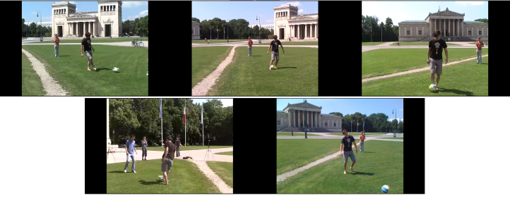
Figure 4. TUM Unsynchronized videos
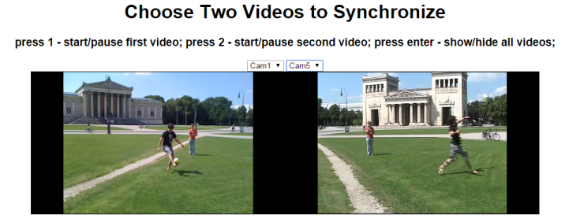
Figure 5. Synchronization interface
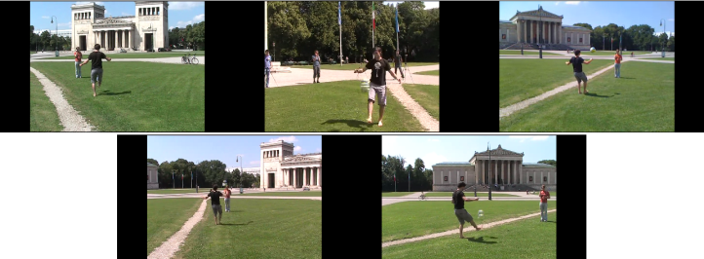
Figure 6. TUM Synchronized videos
Figures 7 and 8 presents the Obama’s video previously without synchronization, and then synchronized.
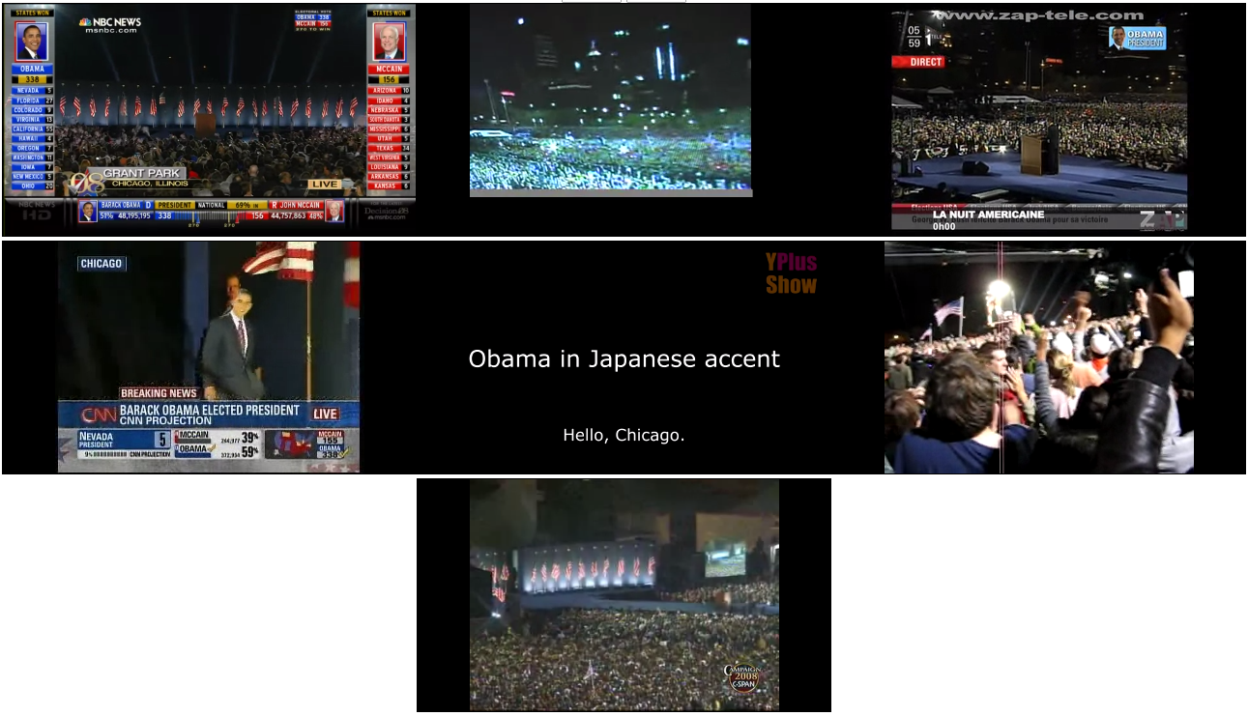
Figure 7. Obama Unsynchronized videos
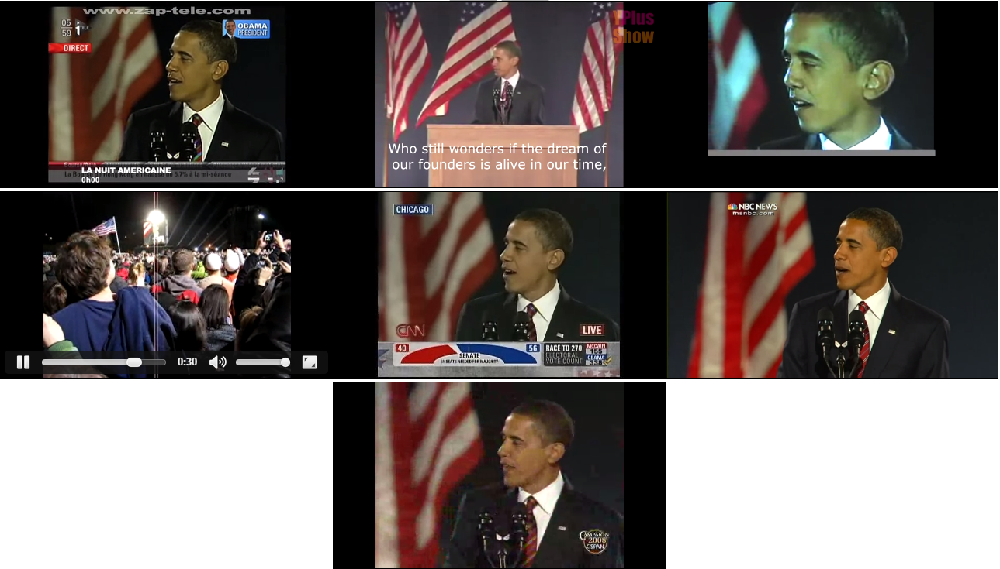
Figure 8. Obama Unsynchronized videos
9. Related Works
Next, we list works that uses some form of crowdsourcing in the video domain. Some of them were already referenced, as they fit in some of the stages of synchronization.
9.1. CrowdSourcing and Vídeos
Papers that relate videos and crowdsourcing may be classified in two main groups: annotations and quality evaluation, hardly being something else.
9.1.1 Annotations
The paper Video Summarization via Crowdsourcing [11] uses the crowd to identify the main occurrences in a video and thus generating a summary.
In Efficiently Scaling up Crowdsourced Video Annotations [12] the crowd is used to annotate multiple videos. Through an interface provided by the authors, users can annotate videos using graphic tools, classifying objects in a video. Besides the annotation, which uses crowdsourcing, the paper presents a complementary approach that helps in annotating videos. Authors use annotations from the crowd as an input to an algorithm that automatically finalizes annotations from a video.
Generating Annotations for How-to Videos Using Crowdsourcing [13] also uses the crowd to generate annotations, however, in this case within a specific context. Authors divide the annotation task in three steps: identifying the time when important events occur; name each event; and identify frames indicating instants before and after the event, helping in the How-To.
Crowdsourcing event detection in YouTube video [16] focuses in generally identifying events in a YouTube video. It features processing in video playback time, to identify scene changes, and then allowing a viewer to annotate that part of the video. However, as stated by authors: “Regarded in isolation, neither of our video event analysis steps is new”. Its contributions are in: (i) scalability through crowdsourcing, (ii) the nature of real time processing in a HTML5 client, and (iii) the combination of annotations for three different types of events (visual event, occurrence event and interest-based event).
A web-based video annotation system for crowdsourcing surveillance videos [18] presents a platform for annotating surveillance videos. A supervisor selects and assigns tasks to users. The paper, despite using the term crowdsourcing , uses the concept of outsourcing, once results from the crowd are not evaluated, neither combined to generate the result. Each individual has to watch the entire surveillance video and annotate it, falling back to the large tasks problem.
Tagging human activities in video by crowdsourcing [21] uses the crowd to annotate scenes in a video, where each participant must annotate its start, end and details of its content to generate an annotation.
9.1.2 Quality
In Quantification of YouTube QoE via Crowdsourcing [15] the crowd is used when evaluating YouTube's quality of services (QoS). For this, it uses the Microworkers platform (microworkers.com). Each crowd individual watches videos from his home and rates his experience. An important point of the paper is the crowd filtering: in multiple tests executions, nearly 80% of them were removed from results as they were considered to fail the evaluation. For the elimination, these techniques were applied: Golden Standard Data; Consistency Tests; Content Quests; Mixed Answers; and Application Usage Monitoring.
Video quality evaluation in the cloud [17] also presents a quality evaluation, but this time an evaluation from the actual video.
A subjective evaluation using crowdsourcing of Adaptive Media Playout utilizing audio-visual content features [20] presents another paper that uses the crowd to evaluate video quality. In this case, issues concerning adaptive video are evaluated. It is asked to participants to evaluate video quality, without knowing if video quality was modified or it remains the same.
9.1.3 Others
Crowdsourced Automatic Zoom and Scroll for Video Retargeting [10] uses the crowd to identify focusing regions of a video. Viewers select a zoom area that focuses important content from the video, so when the video is watched in low resolution screens, only most important content is presented to users.
Introducing game elements in crowdsourced video captioning by non-experts, [19] presents the use of game elements (gamification) in a crowdsourcing platform. In this case, the problem that needs to be solved is generating captions for multiple videos. The most significant about this paper is the use of video segments. This allows users to perform small tasks to achieve a greater goal. Gamification aspects are important as an incentive to participation, instead of monetizing tasks.
9.2. Video Synchronization
Besides studying the relation between crowds and videos, other papers related to video synchronization are of great importance to this study.
Video Snapping: Interactive Synchronization of Multiple Videos [22], from similar videos, synchronizes videos locally and in time, allowing to navigate between videos by resemblance and time. The synchronization works for multiple videos and different cameras.
The paper: Making a Scene [23] presents video synchronization using audio analysis. Fingerprints are generated for each audio, and a comparison between videos is performed, taking into account the number of similar fingerprints: when there are more occurrences, chances of synchronization also increase. It references to parallel videos as OVERLAPING videos, it also presents the use of transitivity between videos to know if an assumed synchronization is true or false.
Discovery and organization of multi-camera user-generated videos of the same event [24] shows another method for synchronizing videos based in their audio. Its approach uses Chroma analysis from audio, grouping and synchronizing audio from a same event. Videos generated by users are called UGV – Unorganized and Unsynchronized User Generated Videos.
Fully Automatic and Frame-Accurate Video Synchronization Using Bitrate Sequences [14] works both as a primary and secondary source for papers in the area. It presents important results in automatic video synchronization, presenting a technique that analyzes differences between frames to find synchronization points between videos. Furthermore, it presents many references that are related to automatic video synchronization.
It also presents main challenges for automatic synchronization algorithms:
“Wide baselines: Approaches that rely on matching texture features suffer from the limited invariance towards view point changes. Hence feature-based approaches not only exclude scenes where the cameras stand opposite to one another but also scenes with wide angle overlapping views.
Camera motion: A “shaking” camera renders many synchronization algorithms unusable. However, the application of video synchronization of casually captured multi-perspective events requires an algorithm that can handle also this kind of scenario.
Dynamic backgrounds: A changing background can confuse any synchronization algorithm in identifying the real object of interest.
Occlusions: Another problematic effect, especially for approaches that involve the tracking of features, is the temporary disappearance of objects of interest, as well as self-occlusions of multiple moving objects.”
10. Final Remarks
Crowds can be used in the most diverse situations: from designing a product to digitizing a word, going through most diverse scenarios, as discovering the structure of a protein. Exploring this variety of uses, this paper presents multiple possibilities of using crowds in the video synchronization process, also its challenges.
Using the crowd allows to address challenges that automatic processing techniques struggle to solve, like: moving cameras, constantly changing backgrounds, disappearing objects and others. A human can handle this problems without affecting his perception about a video, however automatic algorithms struggle in this scenario.
The crowd can further participate in other stages of the process, besides only identifying synchronization points, like in the capture, clustering and verification.
Nevertheless, using crowdsourcing techniques also introduces new problems to the process: how to convoke the crowd to participate; how to validate tasks performed by them; how to integrate results. These are not exclusive problems of using crowdsourcing together with video, but using crowdsourcing generally.
It is possible to have an entire automatic process to synchronize videos, so as an entire crowd based process. However, both cases present limitations: required processing, content interpretation, number of participants, confidence in analyses, etc. This way, hybrid approaches must be considered, joining advantages from each, in a single process that uses crowd and automatic algorithms.
10. References
- D. Irani. The 5-second rule: Agencies devise tricks to keep viewers from skipping ads. The Economic Time Bureau Sep 3, 2014.
- Estelles-Arolas, E.,& Gonzalez-Ladron-de-Guevara, F. (2012). Towards an integrated crowdsourcing definition. JournalofInformation Science, 38(2), 189–200.
- D. Bulterman, R. L. Guimarães, P. Cesar, V. Zsombori, I. Kegel. Personalized Memories of Social Events: Studying Asynchronous Togetherness. Amsterdam. In book: Together Anywhere, Together Anytime: Technologies for Intimate Interactions, Publisher: Centrum Wiskunde&Informatica, Editors: Dick C. A. Bulterman, pp.153-166
- Doan, A., Ramakrishnan, R., & Halevy, A. Y. (2011). Crowdsourcing systems on the World-Wide Web. Communications ofthe ACM, 54(4), 86
- Brabham, D. C., Ribisl, K. M., Kirchner, T. R., & Bernhardt, J. M. (2014). Crowdsourcing applications for public health. American JournalofPreventive Medicine, 46(2), 179–87. doi:10.1016/j.amepre.2013.10.016
- vonAhn, L., Maurer, B., McMillen, C., Abraham, D. and Blum, M. Recaptcha: Human-based character recognition via Web security measures. Science 321, 5895, (2008), 1465–1468
- Cooper, S., Khatib, F., Treuille, A., Barbero, J., Lee, J., Beenen, M., … Players, F. (2010). Predicting protein structures with a multiplayer online game. Nature, 466(7307), 756–60. doi:10.1038/nature09304
- Frantzis, M., Zsombori, V., Ursu, M., Guimarães, R.L., Kegel, I. and Craigie, R. 2012. Interactive Video Stories from User Generated Content: a School Concert Use Case. In: Proceedings of the 5th International Conference on Interactive Digital Storytelling (ICIDS '12), San Sebastian, Spain, November 12-15
- R. M. C. Segundo and C.A.S. Santos, “Second screen event flow synchronization,” Proc. Of IEEE Int. Symp. On Broadband Multimedia Systems and Broadcasting, pp. 1–7, 2013
- Carlier, A., Charvillat, V., Ooi, W. T., Grigoras, R., & Morin, G. (2010). Crowdsourced automatic zoom and scroll for video retargeting. In Proceedings of the international conference on Multimedia - MM ’10 (p. 201). New York, New York, USA: ACM Press.
- Wu, S.-Y., Thawonmas, R., & Chen, K.-T. (2011). Video summarization via crowdsourcing. In Proceedings of the 2011 annual conference extended abstracts on Human factors in computing systems - CHI EA ’11 (p. 1531). New York, New York, USA: ACM
- Vondrick, C., Patterson, D., &Ramanan, D. (2012). Efficiently Scaling up Crowdsourced Video Annotation. International Journal of Computer Vision, 101(1), 184–204.
- Nguyen, P., Kim, J., & Miller, R. C. (2013). Generating annotations for how-to videos using crowdsourcing. In CHI ’13 Extended Abstracts on Human Factors in Computing Systems on - CHI EA '13 (p. 835). New York, New York, USA: ACM Press.
- Schweiger, F., Schroth, G., Eichhorn, M., Al-Nuaimi, A., Cizmeci, B., Fahrmair, M., & Steinbach, E. (2013). Fully Automatic and Frame-Accurate Video Synchronization Using Bitrate Sequences. IEEE Transactions on Multimedia, 15(1), 1–14.
- Hoßfeld, T., Seufert, M., Hirth, M., Zinner, T., Tran-Gia, P., & Schatz, R. (2011). Quantification of YouTube QoE via Crowdsourcing. In 2011 IEEE International Symposium on Multimedia (pp. 494–499). IEEE.
- Crowdsourcing Event Detection in YouTube Videos (2011) by T. Steiner, R. Verborgh, R. Van de Walle, M. Hausenblas, J. Gabarró Vallés
- Keimel, C., Habigt, J., Horch, C., &Diepold, K. (2012). Video quality evaluation in the cloud. In 2012 19th International Packet Video Workshop (PV) (pp. 155–160). IEEE.
- Gadgil, N. J., Tahboub, K., Kirsh, D., &Delp, E. J. (2014). A web-based video annotation system for crowdsourcing surveillance videos, 9027(2009),
- Kacorri, H., Shinkawa, K., & Saito, S. (2014). Introducing game elements in crowdsourced video captioning by non-experts. In Proceedings of the 11th Web for All Conference on - W4A ’14 (pp. 1–4). New York, New York, USA: ACM Press.
- Rainer, B., &Timmerer, C. (2014). A subjective evaluation using crowdsourcing of Adaptive Media Playout utilizing audio-visual content features. In 2014 IEEE Network Operations and Management Symposium (NOMS) (pp. 1–7). IEEE.
- Nguyen-Dinh, L.-V., Waldburger, C., Roggen, D., &Tröster, G. (2013). Tagging human activities in video by crowdsourcing. In ICMR ’13 (p. 263). New York, New York, USA: ACM Press.
- Wang, O., Schroers, C., & Zimmer, H. (n.d.). VideoSnapping: Interactive Synchronization of Multiple Videos. Disneyresearch.com.
- Su, K., Naaman, M., Gurjar, A., Patel, M., & Ellis, D. P. W. (2012). Making a scene. In Proceedings of the 2nd ACM International Conference on Multimedia Retrieval - ICMR ’12 (p. 1). New York, New York, USA: ACM
- Bano, S., &Cavallaro, A. (2014). Discovery and organization of multi-camera user-generated videos of the same event. Information Sciences.
- Dawson, P., Han, I., Cox, M., Black, C., & Simmons, L. (2006). Residence time and food contact time effects on transfer of Salmonella Typhimurium from tile, wood and carpet: testing the five-second rule Journal of Applied Microbiology
- M. Halvey, D. Vallet, D. Hannah, and J.M. Jose. 2009. ViGOR: a grouping oriented interface for search and retrieval in video libraries. In Proceedings of the 9th ACM/IEEE-CS joint conference on Digital libraries (JCDL '09). ACM, New York, NY, USA, 87-96.
- Gilbert, A.; Bowden, R., "iGroup: Weakly supervised image and video grouping," Computer Vision (ICCV), 2011 IEEE International Conference on , vol., no., pp.2166,2173, 6-13 Nov.

